**KITALE NATIONAL POLYTECHNIC DEPARTMENT OF INFORMATION TECHNOLOGY**

**MAMBO HOSPITAL OUTPATIENT MANAGEMENT SYSTEM NAME : CHIRCHIR STACY JEPKOECH**

**INDEX NO : 5031110930**

**COURSE : DIPLOMA IN COMPUTER SCIENCE**

**COURSE CODE : 2205**

**PRESENTED TO**

**KENYA NATIONAL EXAMINATION COUNCIL IN PARTIAL FULFILLMENT FOR A WARD OF DIPLOMA IN COMPUTER SCIENCE AT KITALE NATIONAL POLYTECHNIQUE**

**SUPERVISOR : MR. PETER SOITA**

**EXAMINATION SERIES : NOVEMBER 2022**

# DECLARATION

**STUDENT**

I declare that this is research proposal is my original work and it has not been previously submitted to any institution.

Signature: Date:

**CHIRCHIR STACY JEPKOECH**

**INDEX NO:5031110930**

**SUPERVISOR**

**PETER SOITA**

This team project has been submitted for examination with my approval as The Kitale National Polytechnic’s supervisor.

Signed …………………………………..… Date ………………………………

Mr. Peter Soita

# ACKNOWLEDGMENT

I would like to give thanks to God Almighty for blessing me with life, health and strength to be able to take this task, He is my source of strength whenever I feel like giving up.

I acknowledge the efforts of Mr. Peter Soita for offering to be my guide through this task, he promised to be there ready to advice and help accordingly whenever I face any challenge concerned with this project, which he perfectly did, for that I am grateful. Moreover, I am grateful to the Kitale National Polytechnic for providing me this opportunity to undertake this project together with providing the relevant materials that I may need to this process through.

Lastly, I acknowledge my parents for always being there for me and offering their full support throughout this project.

# DEDICATION

This research and project are dedicated to my loving parents whose efforts, love and providence has seen me to this far and the future to come. They are and always will remain the source of my inspiration and handwork and thus is only fit that this research be dedicated to them for their outstanding parenthood.

# ABSTRACT

People are much aware of the fact that, “to keep body in a good health is a duty; otherwise, we shall not be able to keep our mind strong and clear”. The well-known avenues for seeking medical attention are hospitals and clinics. Both administrators and doctors in these lifesaving avenues spend an awful lot of time handling and manually processing patients’ medical records, and other related details. Handling this kind of activities is becoming harder and harder, due to the exponential growth of the number of patients that are trooping into both government and private hospitals seeking for medical attention. Globalization and modern-day innovations have led to the intensive use of Information and Communication Technology (ICT) in minimizing problems and easing most of our day-to-day activities to which medical activities are no exception. With this in mind, then, there is the quest of developing sophisticated tools to ease these onerous and tedious tasks. This paper titled presents the research, design and implementation of intuitive software in this regard. The software was developed by adopting the waterfall model and using Hypertext Markup Language, JavaScript, Bootstrap CSS, Hypertext preprocessor (PHP), MYSQL in XAMPP server and Visual Studio Code as the development tool. Furthermore, it is based on the popular 3-tier architecture pattern, consisting of the presentation tier (user interface); logic tier (business rules translated into a concrete implementation); and the database/storage tier (for storing patients’ details). The work has presented a promising serene hospital environment, where records are kept in computerized forms for easier and quicker access thereby minimizing the waiting and consultation times of patients in a hospital.

**Keywords**: ICT, Patient, Software, Hospital

# TABLE OF CONTENTS

DECLARATION ii

ACKNOWLEDGMENT iii

DEDICATION iv

ABSTRACT v

TABLE OF CONTENTS vi

CHAPTER ONE: INTRODUCTION 1

1.0 Introduction 1

1.1 Background of the Study 1

1.2 Statement of the problem 2

1.2.0 Waiting Time 2

1.2.1 Patients’ Appointment System 2

1.2.3 Appointment Delay 3

1.2.4 Managing Patients’ Appointment System 3

1.3 The purpose of the study 4

1.4 Objectives of the Study 4

1.4.1 General Objectives 4

1.4.2 Specific Objectives 4

1.5 Research questions 4

1.6 Significance of the study 4

1.7 Scope of the Study 5

CHAPTER TWO 6

LITERATURE REVIEW 6

2.1 Introduction 6

2.2 REVIEW OF RELATED STUDIES 6

2.3 BOUT THE SYSTEM 6

2.4 FEASIBILITY STUDY 7

2.5 DOCUMENT INVESTIGATION 7

2.6 SYSTEM ANALYSIS 8

2.7 SYSTEM INVESTIGATION 8

CHAPTER THREE 9

METHODOLOGY 9

3.1 Introduction 9

3.1.1 Online Booking System 9

3.1.2 Existing Hospital Appointment Schemes 10

3.2 Software development life cycle 10

3.2.1 Original Methodologies 12

3.3 Selection of Methodology 15

3.4 Justification of the Selected Methodology 15

3.5 Location of the Study 16

3.6 Research Design 16

3.7 Data Collection 16

3.7.1 Questionnaire 16

3.7.2 Observation 17

3.7.3 Data Analysis 17

CHAPTER FOUR 19

SYSTEM ANALYSIS AND DESIGN 19

4.0 Design Diagrams 19

4.0.1 Use-case Diagram 19

4.0.2 Data Flow Diagram 20

4.1 The Online Medical Appointment Booking System 20

4.2 Patient Registration Menu 20

4.3 Patient Activity Menu 21

4.4 Patience Input Specification 21

4.5 Output Specification 23

4.6 Doctor Function 23

4.7 Conclusion 24

CHAPTER FIVE 25

SYSTEMS IMPLEMENTATION AND TESTING 25

5.1 Introduction 25

5.2 Hardware and software requirements 25

5.1.2 Software Requirements 26

5.3 Samples of code used 26

5.4 Implementation Strategies 28

5.5 Testing strategies 29

5.6 Test plan 29

5.6.1 Unit testing 29

5.6.2 Module Integration and Testing 29

5.6.3 System Testing 30

5.6.4 Acceptance testing 30

5.7 Justification of testing and implementation strategy 30

CHAPTER SIX 31

CONCLUSION AND RECOMMENDATIONS 31

6.1 Introduction 31

6.2 Achievements 31

6.3 Lessons Learnt 31

6.3 Recommendations 32

APPENDICES 33

REFERENCES 35

# CHAPTER ONE: INTRODUCTION

## 1.0 Introduction

This chapter presents the background of the study, the objectives of the study, the research questions, the scope, and the limitations of the study and the justification of the study.

## 1.1 Background of the Study

Before Healthcare System came into practice, keeping proper records of the daily activities of hospitals, patients’ information, maintenance schedule of equipment in hospitals, as well as the allocation and usage of funds happened to be a difficult and hectic task. This resulted in waste of money, time and manpower. Healthcare System is an information management system designed to help manage administrative, clinical and financial aspects of our modern-day hospitals. It helps in monitoring and controlling hospitals’ daily transactions, as well as their overall performances. Hospital Management System enables access to the right information and automation of complex tasks, hence allowing staff to spend more time caring for patients than any other related but less important task.

Research on outpatient clinics shows that waiting times are patients’ main dissatisfaction with hospital services. According to doctors and other personnel, overtime and peak workloads are potential threats to the quality of services offered by hospitals across the globe. This research focuses on outpatient scheduling as a means of solving these problems for outpatient clinics, with the overall aim of enhancing the services provided by these clinics. According to the Oxford Dictionary access time is the time between the patient’s request for an appointment and his arrival at the outpatient clinic. A patient’s internal waiting time is the period between the scheduled starting time and the actual starting time of his consultation. Waiting time due to a patient’s early arrival is extracted from the internal waiting time, since it is not a consequence of the appointment system.

To address the above-mentioned problems, there is the thirst of automating the entire process, to help patients book for appointments and access their medical records online. This will significantly reduce the number of missed appointments, unnecessary outpatient queue at the clinics, and long waiting time. The system will enable the outpatients to login with their number to appointment booking interface and view the scheduling calendar for the available receptionist, available time of the available physicians. Then book an appointment by selecting from the list of available personnel’s that conform to the patient time. This paper presents the research, design and implementation of intuitive software in this regard. The software was developed using Hypertext Markup Language, JavaScript, Bootstrap CSS, Hypertext preprocessor (PHP), MYSQL in XAMPP server and Visual Studio Code as the development tool.

## 1.2 Statement of the problem

#### 1.2.0 Waiting Time

Waiting time simply means a period of time which one must wait in order for a specific action to occur, after that action is requested or mandated. Patients’ waiting time has been defined as “the length of time from when the patient entered the outpatient clinic to the time the patient actually received his or her prescription”. It is defined as the total time from registration until consultation with a doctor. There were two waiting times, the first is time taken to see a receptionist and the second is time to obtain medicine. This paper deals with the waiting time to see physicians.

Long waiting times are a serious problem for patients using urban health centers in developing countries. A block appointment system was introduced and evaluated in a large South African health center. Waiting times of all patients were measured over oneweek period before and after the implementation of appointments. Focus groups and individual interviews were conducted with staff and patients. After introducing appointments, patients with acute and chronic illnesses and having appointments had significantly shorter waits time than similar patients without appointments.

#### 1.2.1 Patients’ Appointment System

A patient appointment system or appointment schedule for health care center started long time ago. Management of patients’ appointments has earlier worked and has developed simplified queuing models and fairly static scheduling conditions. Another attempt was made to calculate the waiting time between patient and doctor using the mathematical queuing models to minimize waiting time. However; traditionally, the appointment system has considered that the doctor time is more important than patient time. So an appointment system was designed to minimize the doctor idle time but current designing of an appointment system is based on decisive factors with respect to both the patient and doctor.

#### 1.2.3 Appointment Delay

Past research shows that the longer the appointment delay which is defined as the time between the day a patient requests an appointment and her actual appointment date, the higher the chances that he/she will cancel or not show up. This suggests an obvious way of minimizing no-shows and cancellations: this is done by asking the patients to come right away or make appointment requests on the day they want to be seen. This is called an open access (OA) or advanced access policy, and of late it has become a popular paradigm in practice and the subject of active research. Several authors report on their experiences in implementing OA, both positive and negative. Some practitioners strongly advocate OA, and there are some who are strongly against it.

#### 1.2.4 Managing Patients’ Appointment System

According to a study, managing patient appointment system is a computer application used to manage and reduce the patient waiting time in the health care center. Some health care centers do not use any appointment system. So, it has a longer average patients’ waiting time than the health care center that adopts the patients’ appointment system. While patients can wait for more than one hour to be attended to by a physician in a health care center, they also can feel that they are being disregarded and treated unfairly. So, when patients are given the time of appointment in a health care center, they can evaluate the quality of service in the center.

Hence, developing patients’ appointment process for health care centers necessitates the use of a sophisticated queuing model that captures much of the real system’s features (saving time, reducing idle time, etc.). Therefore, the appointment schedule represents the real situation in the health care center faced by patient appointment schedulers. On the other hand, the standard practice for scheduling and processing patient appointments are based on the nature of treatments of the patients and that better approaches more sensitive to patient needs are desirable.

## 1.3 The purpose of the study

This study is aimed at conducting research on the extent of patient satisfaction with the existing medical procedures that are in place, effects and challenges of traditional methods of medical care administration to an individual and proposes a system that will help streamline and improve medical care administration.

## 1.4 Objectives of the Study

#### 1.4.1 General Objectives

To develop a web-based outpatient management system.

#### 1.4.2 Specific Objectives

1. To gather the requirements of the system.
2. To design the web-based outpatient management system.
3. To implement the web-based outpatient management system.
4. To test and verify the web-based outpatient management system.

## 1.5 Research questions

1. How will the system requirements be gathered?
2. How will the outpatient management system be designed?
3. How will the outpatient management system be implemented?
4. How will the outpatient management system be verified?

## 1.6 Significance of the study

This study will analyze the existing medical administration procedure in the current world with a specific focus on Kenya as a developing country. This study after the analysis will propose a webbased solution for the long medical administration procedures and might prove useful to reducing the waiting time for patients in Kenya and the whole world at large.

## 1.7 Scope of the Study

The study is will explore the currently available patient medical attendance methods, check their impact and decide whether they are efficient or not. The study will also explore the various methods that the Kitale District Hospital use to try and better patient attendance procedures. At the end the study will propose a possible solution to the problem of long waiting times in the hospitals in Kenya.

# CHAPTER TWO

# LITERATURE REVIEW

## 2.1 Introduction

This chapter reviews a wide range of literature from earlier studies, with an emphasis on the development and application of web-based outpatient management systems. It examines projects and research conducted by other academics in related fields. This chapter contains highly prioritized data and surveys from published publications on this planned outpatient management system. The following topics are covered in this chapter: Review of theoretical literature, adoption theories that influenced the research, conceptual framework, and conclusion.

## 2.2 REVIEW OF RELATED STUDIES

Outpatient management Systems have been widely adopted in many hospital levels of which computerize their operations. It has proved to be very effective, reliable, fast and accurate. Different departments and individuals have contributed to their support of Hospital outpatient management system. This includes:

The rapid advancement of Information and Communication Technologies (ICT) in patient scanning has shifted the paradigm by Uysal&Kuzu,(2009) from paper-pencilbased to computer-based system of patient which are usually termed as Computer Assisted checking.

Due to the inclusion of ICTs in patient management, it is required to re-consider and rethink, modify or change the traditional patient treatment. Electronic patient management tools had reduced the burden of Doctors

Various patient treatment used in hospitals to assess the process of treating, for example, paying money to the Doctor directly so that he/she looks for painkillers.

## 2.3 BOUT THE SYSTEM

The proposed Hospital outpatient management system is a single user system which will enable a person to use at given time, hence only the operator authorized will be able to access the information. The user must login to the system so as to access the information. The system has ability to register and record many patients, doctors.

## 2.4 FEASIBILITY STUDY

This is the process of clearly understanding of the current system and is the activity carried out in the organization of any management. Therefore, having enough information/feasibility study about the Mambo hospital outpatient Management System, I have found there are a lot of problem arising during the treatment of patients. However, these problems can be minimized if the system will be automated.

##### OPERATIONAL FEASIBILITY

The system performs its task at a lower rate, hence there is a lot of time wasted and in turns it does not meet the requirements of the end user.

##### ECONOMICAL FEASIBILITY

The current system wastes a lot of time, and it is error prone which leads to wastage when patients needs to attended on.

##### MERITS OF THE PROPOSED SYSTEM

* Serves on time of patient treatment.
* Accuracy on the calculation of costs of the patient.

##### DEMERITS OF THE PROPOSED SYSTEM

* Language barrier since other terminological terms more misunderstanding.
* Time consuming since other respondent may want to take their time giving response.

## 2.5 DOCUMENT INVESTIGATION

Searching of information through existing files include following the organization charts and job description.

##### MERITS

* Help analyst to get background information.
* The actual facts are recorded.

##### DEMERITS

* The data may be incomplete hence no adequate information.
* May obtain outdated data.

## 2.6 SYSTEM ANALYSIS

System analysis is the total understanding of the current system by gathering and interpreting facts, diagnosing the problems using the facts to improve the system. After the system feasibility is done, the system analyst takes a formal way in which the proposed system is to be accepted or not. Therefore, the activities include, determining the system requirements of to be included in the proposed system.

## 2.7 SYSTEM INVESTIGATION

This involves detecting the areas in the current system that work manually to be automated, or the areas that have feasibility problems, to be corrected.

# CHAPTER THREE

# METHODOLOGY

## 3.1 Introduction

This chapter will provide an in-depth analysis of the technique that will be employed in the project's development phase. This section will outline the strategies and techniques that will be used to collect relevant data and analyze the information acquired in order to aid in the achievement of the goals. Research methodology is the study of the methods by which humans acquire knowledge; it is concerned with the cognitive processes imposed on research by challenges deriving from the subject matter's nature. The procedures for generating and assessing data are referred to as research methods. The software development life cycle is described in this chapter, as well as the methodology, justification for the methodology chosen, study location, research design, target population, sample size, research instruments, data collecting, and data analysis.

#### 3.1.1 Online Booking System

An online system is also known as a web-based system. A web is made up of page that is commonly known as web page or web site, and a web site is a computer program that runs a web server that provides access to a group of related web pages. A system is a set of independent components working together to achieve a common objective. Therefore, a web-based system is a system that is accessible over the internet by a user in order to achieve a particular task for a given purpose. The Internet is a system that is used to connect computers and computer networks. It helps to link millions of computer networks all over the world and it allows the users to get information stored on other computers from a long distance. A web-based appointment system is used in Taiwan; everyone is required to enroll in the national health insurance program. When one needs health service, he shows his health insurance card to doctors in a hospital to start with. There are several ways of making an appointment. A person can either go to the hospital directly for consultation day by day or make an appointment from home through phone call or email if his condition is not emergent. The Internet provides a wide range of technologies that enable hospitals to communicate with their patients. Recently, as the prevalence of Internet increasing, many hospitals initiated the website appointment system. Electronic patient-provider communication promises to improve efficiency and effectiveness of clinical care.

#### 3.1.2 Existing Hospital Appointment Schemes

One application developed to manage patients’ appointment scheduling has used exponential Inter arrival times. This model assumes that the exponential enter arrival times could not be directly validated by date, and it is limited due to the nature of the appointment scheduling. Since appointments are scheduled in the future, the exact model of call arrivals will only have limited impact on measures related to the time between the call and the appointment time. For this reason, the challenge for making appointment system is designing a suitable system based on the health care procedure environment. Hence, the appointment provider in the health care center can schedule a patient into an appropriate time slot on a given day.

## 3.2 Software development life cycle

The software life-cycle is a methodical approach to software development that ensures the quality and correctness of the final product. Its goal is to provide high-quality software that matches consumer needs. Some of the phases are included.

##### Stage 1: Planning and Requirement Analysis

This is the most critical and fundamental level of the SDLC.I carried it out with feedback from customers and other stakeholders. I met with various stakeholders from the problem domain and attempts to elicit as much information as possible about their needs. The requirements were gathered using the following methods: examining existing or defunct systems and software, conducting user and developer interviews, consulting a database, or gathering responses from questionnaires. This data was then utilized to establish the core project approach and undertake a product feasibility analysis in the economic, operational, and technical realms.

##### Stage 2: Feasibility study

After gathering requirements, I created a basic software process plan. It was at this stage, that I determined that the software could be built to meet all of the user's criteria. I also determined that the project is financially, practically, and technologically possible for the me to undertake. I made use of the software requirement specifications document to guide this process.

##### Stage 3: System Analysis

At this point, I decided on a plan's road map and strive to come up with the optimal software model for the job. Understanding the constraints of software products, learning about system-related problems or modifications that need to be made in existing systems ahead of time, identifying and resolving the project's influence on the organization and personnel, and so on are all examples of system analysis. I evaluated the project's scope and allocated resources and timeline accordingly.

##### Stage 4: Design

The next stage was to gather all of the requirements and analytical information on the desk and build the software product. This step's inputs are user inputs and information obtained during the requirement gathering phase. The result of this step was logical design of which I came up with prototypes of the system to be developed

##### Stage 5: Coding

During this phase, I began to design the entire system by writing code in HTML, JavaScript, Bootstrap Css, MYSQL and the PHP programming language for the web application, I efficiently developed error-free executable program.

##### Stage 6: Testing

Software testing was done as the coding activity progressed, and rigorous testing was done by some of my developer connects at various levels of code, such as module testing, program testing, product testing, in-house testing, and user testing. Defects in the product were reported, tracked, rectified, and retested until the product met the quality standards.

##### Stage 7: Implementation

During this phase, software was tested for portability and adaptability, and integration concerns were resolved.

##### Stage 7: Operation and Maintenance

This step was crucial to ensure that the programs are operating at a higher level of efficiency and with fewer faults. As necessity entails, a sample of users were trained and provided with instructions on how to operate and maintain the software. The programs were kept up to date by upgrading the code in response to changes in the user end environment or technology.

#### 3.2.1 Original Methodologies

3.2.1.1 Waterfall method

It is also referred to as sequential life cycle model. It is the simplest model of software development paradigm. All the phases of SDLC will function one after another in linear manner. That is, when the first phase is finished then only the second phase will start and so on. This model assumes that everything is carried out and taken place perfectly as planned in the previous stage and there is no need to think about the past issues that may arise in the next phase. This model does not work smoothly if there are some issues left at the previous step. This model is best suited when developers already have designed and developed similar software in the past and are aware of all its domains. All these phases are cascaded to each other in which progress is seen as flowing steadily downwards through the phases. The next phase is started only after the defined set of goals are achieved for previous phase and it is signed off, so the name "Waterfall Model". In this model, phases do not overlap.

**Diagram of Waterfall-model:**

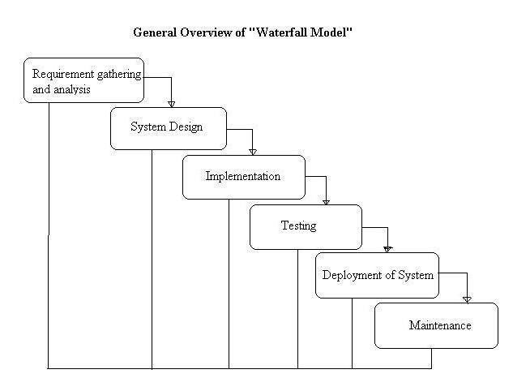

##### Figure 1: water fall model

Some situations where the use of Waterfall model is most appropriate are −

* Requirements are very well documented, clear and fixed.
* Product definition is stable.
* Technology is understood and is not dynamic.
* There are no ambiguous requirements.
* Ample resources with required expertise are available to support the product.
* The project is short.

The advantages of waterfall development are:

* Simple and easy to understand and use
* Easy to manage due to the rigidity of the model. Each phase has specific deliverables and a review process.
* Phases are processed and completed one at a time.
* Works well for smaller projects where requirements are very well understood.
* Clearly defined stages.
* Well understood milestones.
* Easy to arrange tasks.
* Process and results are well documented.
* The disadvantages of waterfall development include:
* No working software is produced until late during the life cycle.
* High amounts of risk and uncertainty.
* Not a good model for complex and object-oriented projects.
* Poor model for long and ongoing projects.
* Not suitable for the projects where requirements are at a moderate to high risk of changing.

So, risk and uncertainty are high with this process model.

* It is difficult to measure progress within stages.
* Cannot accommodate changing requirements.
* Adjusting scope during the life cycle can end a project.
* Integration is done as a "big-bang. at the very end, which doesn't allow identifying any technological or business bottleneck or challenges early.

## 3.3 Selection of Methodology

Agile System Development Methodology is the methodology that was employed. Extreme Programming (XP) is one of the most well-known agile development life cycle models for developing software in an unbalanced environment. Prototyping is a part of agile development. Knowledge system prototyping was a useful strategy for swiftly acquiring precise information about consumers' information needs. To emphasize the relevance of prototyping as an informationgathering approach, it was incorporated in the process. It also proved an asset for the observation of first reactions from users and management to the prototype, as well as user suggestions for changing or improving it.

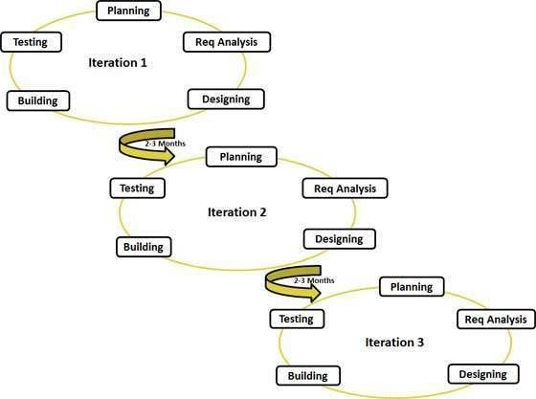

*Figure 1: The Software Development Life Cycle Diagram for The outpatient hospital management System*

## 3.4 Justification of the Selected Methodology

The Agile System Development Methodology ensured that there was a timely delivery of usable software and in a consistent manner that satisfies customers. It ensured that a working software was routinely given to the customer so as for them to suggest changes and increase the software chances of acceptability. It provided a cconsistent focus on technological and design quality of the software thus making sure that the end software was of high quality.

The methodology has the capability of adapting the software to new circumstances on a regular basis thus enabling the incorporation of high quality and on-demand features. It provided room for even last-minute demand adjustments being that it is a flexible methodology.

It is also a high efficient methodology as it requires little amount of resources apart from allowing for quick development and showcase of functionalities.

## 3.5 Location of the Study

The research took place in the Kitale District Hospital located in Kitale town in the Trans-Nzoia County of the republic of Kenya.

## 3.6 Research Design

The research design implemented in this study was the Explanatory research, this is because the research’s basic goal is to determine the limits of the environment in which the issues, opportunities, or circumstances of interest are likely to exist, as well as the important components or variables that may be located there and be relevant to the research.

## 3.7 Data Collection

#### 3.7.1 Questionnaire

There was administration of both closed-ended and open-ended questions on the questionnaires. The research objectives were used to create questionnaires. Questionnaires were preferable since they are simple to use and save time (Creswell, 2013).

There was few open-ended questions that produced qualitative data on subjective thoughts and responses connected to the anti-counterfeit systems currently available as well as expected system characteristics. Those who could not interpret the questionnaires filled out self-administered questionnaires. I distributed questionnaires to respondents who, due to their educational or literacy skills, were unable to easily interpret the questions.

Questionnaires, as a data collection strategy, gave a relatively inexpensive and efficient way of collecting huge amounts of data from a broader population. Data was acquired in a relatively short period of time. Questionnaires proved an excellent way for measuring the behavior, attitudes, preferences, opinions, and intentions of a large number of individuals at a lower cost and faster rate than other methods.

#### 3.7.2 Observation

As the name implies, observation is a method of gathering information by observing. This was preferable since I had to immerse myself in the context where my respondents were, while taking notes and making records, being that observation as a data collection approach is characterized as a participatory study.

Observation sessions were carried out in the named different sections of the nation. This brought in the necessary data that drove forward and justified the development of the system.

This technique was preferable since it offered direct access to study phenomena, high levels of application flexibility, and the creation of a permanent record of events to be referred to later. Despite these advantages, the observation approach had its drawbacks for instance it involved lengthier time requirements, high chances of observer bias, and observer impact on primary data, which means that the presence of an observer may influence the behavior of sample group parts.

It is also worth noting that the observation data collection approach could easily be linked to some ethical concerns such as obtaining fully informed permission from research participants and at the same time, if sample group members are informed of the observer's presence, their behavior may change, which may have had a detrimental impact on the research validity.

#### 3.7.3 Data Analysis

Both quantitative and qualitative data analysis methods were applied in this study for instance quantitative data being concerned with quality and factual data was relevant since such parameters as sales numbers and marketing data such as payrolls collected had to be analyzed. In the other hand, qualitative data which is mostly concerned with characteristics of an organization that are interpretive and subjective such as the data from customer surveys, employee interviews, and a focus on quality over quantity, were also analyzed. The techniques used to measure the quantitative data included Hypothesis testing and regression analysis whereas the following two strategies were used for qualitative data: content analysis and narrative analysis

##### Content Analysis

This strategy was effective since it aided in deciphering the broad themes that arose from qualitative data. Color coding distinct themes and concepts aided in the parsing of textual material to locate the most prevalent threads of counterfeiting. When dealing with data such as user feedback, interview data, open-ended surveys, content analysis were quite useful. This assisted in determining the most critical areas for improvement.

##### Narrative analysis

This type of analysis proved applicable since it focuses on how stories and ideas are disseminated throughout a business, and it helped in better understanding of the culture of the communities and the population that was studied. Interpreting how farmers feel about their jobs, how consumers perceive an organization, and how operational procedures are perceived were the scope of this analysis.

# CHAPTER FOUR

# SYSTEM ANALYSIS AND DESIGN

## 4.0 Design Diagrams

### 4.0.1 Use-case Diagram

The use case diagram is used in presenting the system requirements of any proposed system. A use case is a realistic description of the workflow of the system and it is used to explicitly describe the intentions and actions of users. The use case diagram, which present the system requirements are used to show how the proposed system work in practice. The interaction between actor and use cases are also described using use case diagram. The use case diagram of the medical appointment booking system is presented in figure 2 below.

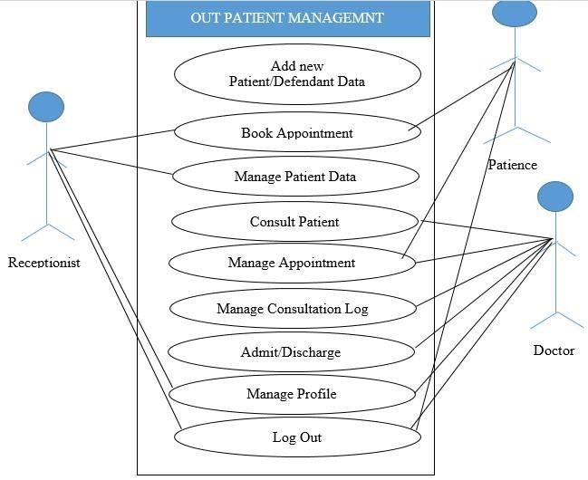

Figure 2: Use-case Diagram of the Proposed System

### 4.0.2 Data Flow Diagram

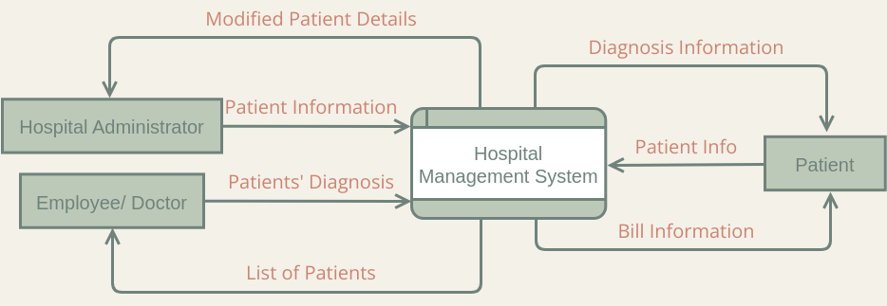

## 4.1 The Online Medical Appointment Booking System

The user interface allows the user to navigate the system and communicate with the database. The system interface design is simple enough to be the use for anyone with little knowledge of computer operation. Furthermore, it is user friendly and made easy to use through the use of Windows, Interface Menu and Pointing devices (WIMP), which is very important in computer graphics design. The inputs to the online medical appointment booking system are captured through the user interfaces available in administrator’s account and the individual patient’s account. A login Menu, which contains a user-friendly interface for capturing valid registration code, username and password, is available for each patient to logging in to their various accounts. In each patient account, data pertain to the patient and available doctor are entered and appointment booked are submitted. All these captured data are stored in the database.

## 4.2 Patient Registration Menu

There is need for every new patient to register before they can access the system, a patient must have a username and password which they will use to login before they can book for medical appointment. Any patient that does not register will not be allowed to access appointment booking Menu because to login to the appointment Menu requires a username and a password.

## 4.3 Patient Activity Menu

The patient activity Menu which is depicted in the figure below displays the list of links of operation that a patient can perform with the system; the following are the activities a patient can perform.

* Appointment Booking
* View Appointment Report
* Log Out

## 4.4 Patience Input Specification

Patience Inputs can be described as raw materials that put into system for processing. The system can accept input from keyboards, mouse or touch pad. The System will collect Patient raw data as shown in figure 3

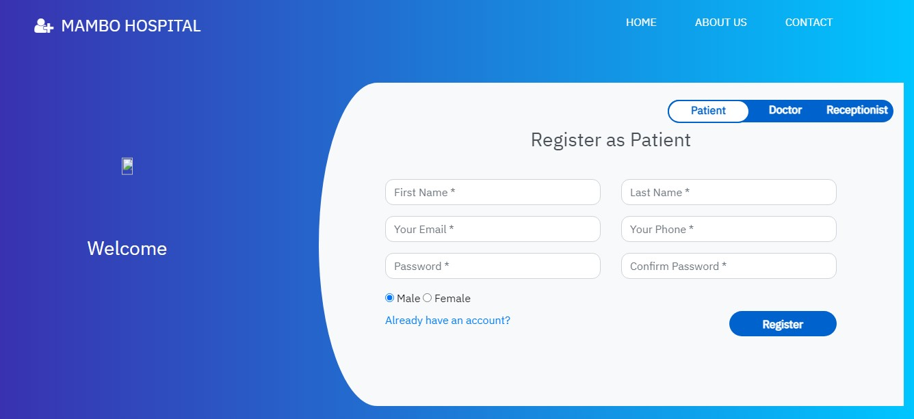

Figure 3: Patient Data Input Form

Patient Data Form provides input to the system in which user is to fill out all necessary details of the patient for the doctor to view during the consultation and for record keeping purpose.

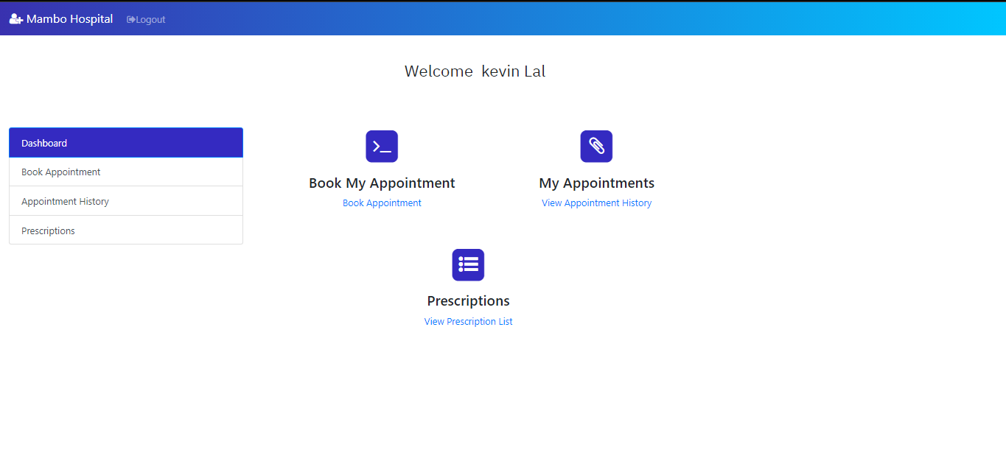

Figure 4: Defendant Data Input Form

A defendant is a sub child or sub file attached to a Patient whom he referencing as Family, Company or group file. Any Individual patient can be a dependee while defendant ID is derived from depended ID. The figure above describes all the necessary input needed to fill out dependent form.

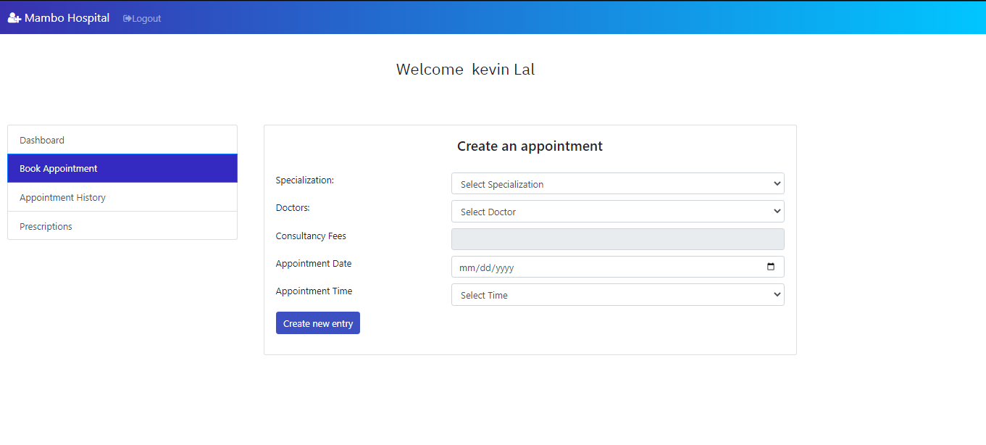

Figure 5: Appointments Booking Inputs

## 4.5 Output Specification

An output is the information provided as a result after input data have been processed. The output input is set to be printed or view for retrieval purpose. The major output information is patients’ records and consultation page as shown in figure 6.

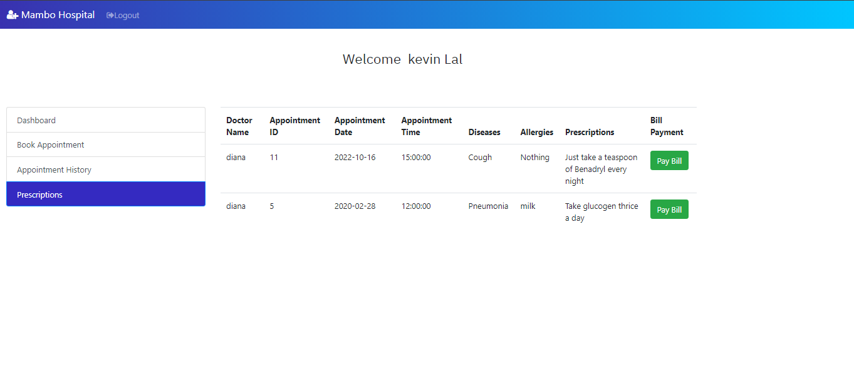

Figure 6: Patient Data Card

The figure 6 above is an automated Data Card printed after a successful registration of new Patient (Individual or Defendant). The receptionist will print the form and issued it to the Patient for referencing purpose. Each visitation, a patient is expected to issue his Unique ID to doctor for him to retrieve his Personnel details.

## 4.6 Doctor Function

Doctor function is carried out by doctor whom will consult people through their consultation details that are understandable by any other concern doctor. Also doctor can view patient details and see his consultation history. In addition, doctors can manage their appointments, reschedule them or approve them upon their decisions.

## 4.7 Conclusion

With the development of healthcare medical appointment booking system, patients are able to book and manage their own appointment with ease. They will be reminded of their appointments via SMS/email that will be promptly sent to them before their appointment date. The system itself also provides a quick view of their appointment at the home page. These functions could indirectly help to reduce the number of missed medical appointments and patient’s no-show up for their appointment. Patients would be notified via SMS/email if their appointment were affected, when there are urgent needs of the service provider at other place or in case of any situation that can result to the absence of the service provider.

Patients could also track and monitor their appointment record with this system. However, the display of bio-data such as X-rays and laboratory results are not included in the system due to technical constrain. The system will not be able to diagnose or prescribe drug for usage. The system is mainly designed to facilitate appointment booking between the patient and the health personnel. In compensation, additional modules such as Announcement, Medical case record and block/unblock schedule will further enhance the usability and functionality of the system and allow a flexible management of patient’s appointment.

The system delegates some administrative work to the patients by allowing them to manage their own appointment and personal profiles. Time will not be wasted on converting paper-based appointment record into electronic-based. The system further helps to reduces healthcare personnel workload by allowing them to generate medical reports easily. They could now maximize their competence and allocate more time to maximize service quality.

# CHAPTER FIVE

# SYSTEMS IMPLEMENTATION AND TESTING

## 5.1 Introduction

The Hospital Outpatient Management system's deployment and testing processes are described in this chapter. It covers implementation techniques, system changeover, module integration and testing, coding, programming languages, software and hardware requirements, and data models.

## 5.2 Hardware and software requirements

##### 5.2.1 Hardware Requirements

|  |  |
| --- | --- |
| **Computer requirements** | **Minimum System requirement** |
| **Processor** | 2.4 GHZ processor speed, 64-bit |
| **Memory** | 2 GB RAM |
| **Disk space** | 100GB |
| **Phone requirements** |  |
| **Camera** | 8 megapixels |
| **Network card** | 3G, 4G capabilities |

**Hardware**

*Table 1: Hardware Requirements*

The table above lists the hardware components of the machine on which the system should run and perform properly.

#### 5.1.2 Software Requirements

The table below provides the minimum software requirements for a certain computing device to operate the system. **Computer**

|  |  |
| --- | --- |
| **Software** | **Minimum System requirement** |
| **Operating System** | Windows 7 or later but Linux environment is highly preferable |
| **Applications** | Python support |
| **Run-time Environment** | Visual studio code Python 3 |
| *Table 2: Computer Software Requirements*    **Smartphone** |  |
| **Software** | **Minimum System requirement** |
| **Operating System** | Android |
| **Applications** | browser |
| **Run-time Environment** | Android |

*Table 3: Smartphone Software Requirements*

## 5.3 Samples of code used

<html>

<head>

<title>HMS</title>

<link rel="shortcut icon" type="image/x-icon" href="images/favicon.png" />

<link rel="stylesheet" type="text/css" href="style1.css">

<link href="https://fonts.googleapis.com/css?family=IBM+Plex+Sans&display=swap" rel="stylesheet">

<!-- <link rel="stylesheet" href="https://stackpath.bootstrapcdn.com/bootstrap/3.4.1/css/bootstrap.min.css" integrity="sha384-

HSMxcRTRxnN+Bdg0JdbxYKrThecOKuH5zCYotlSAcp1+c8xmyTe9GYg1l9a69psu

" crossorigin="anonymous"> -->

<link rel="stylesheet" href="https://stackpath.bootstrapcdn.com/bootstrap/4.3.1/css/bootstrap.min.css" integrity="sha384-

ggOyR0iXCbMQv3Xipma34MD+dH/1fQ784/j6cY/iJTQUOhcWr7x9JvoRxT2MZw1 T" crossorigin="anonymous">

<link rel="stylesheet" href="vendor/fontawesome/css/font-awesome.min.css"> <link href="//maxcdn.bootstrapcdn.com/bootstrap/4.1.1/css/bootstrap.min.css" rel="stylesheet" id="bootstrap-css">

<style >

.form-control { border-radius: 0.75rem;

}

</style>

<script> var check = function() { if (document.getElementById('password').value == document.getElementById('cpassword').value) { document.getElementById('message').style.color = '#5dd05d'; document.getElementById('message').innerHTML = 'Matched';

} else { document.getElementById('message').style.color = '#f55252'; document.getElementById('message').innerHTML = 'Not Matching';

}

}

function alphaOnly(event) { var key = event.keyCode; return ((key >= 65 && key <= 90) || key == 8 || key == 32); };

function checklen()

{ var pass1 = document.getElementById("password"); if(pass1.value.length<6){ alert("Password must be at least 6 characters long. Try again!"); return false;

}

}

</script>

## 5.4 Implementation Strategies

The process of installing software and hardware and getting the system up and running is known as system implementation. Agile methods were used to develop this software. The agile methodology divided the project into discrete modules, with testing and feedback phases in between. The methodology divided the system software implementation into a number of selfcontained segments, each of which delivered a measurable business result. It also made sure that the users became accustomed to the system's operation, flexibility, and utility, as well as provided individual training to prepare users for the Outpatient management system.

## 5.5 Testing strategies

This represents the testing methods that were employed in this project. They outline how the product risks were addressed at the test level, as well as the types of testing conducted and the entry and exit criteria used.

## 5.6 Test plan

A test plan provides a comprehensive document that includes the test strategy, testing objectives, testing resources, test schedule, test estimation, and test deliverables.

This proved efficient in guiding the development of a comprehensive and completely integrated system guaranteeing that all user needs were met and all system capabilities executed smoothly and without glitches.

These are the two types of software testing that were performed:

* Blackbox testing
* Whitebox testing.

#### 5.6.1 Unit testing

During this testing, I performed a test on each module of code, being that I wrote and developed the system.

#### 5.6.2 Module Integration and Testing

Integration testing, often known as integration and testing, it was instrumental in this project. It encompassed the whole process in which program modules were merged and tested in as a group. Integration testing revealed issues with several of the software component interfaces. The goal of integration testing was to ensure that data is communicated between various parts of the project. Here, all of the units were brought together and tested at the same time. The goal of the module integration test was to ensure that the modules were compatible and that they could operate together to build a fully functional system.

#### 5.6.3 System Testing

In this phase, the testing was on the completed software product before it’s release to the general public. The testing was based on a variety of factors, including the system's usability, recovery, and functioning, among others.

#### 5.6.4 Acceptance testing

This was done when the system was put to the test by the users themselves. It was used to determine whether the system met the needs of the clients and whether they would accept it.

## 5.7 Justification of testing and implementation strategy

When designing an object oriented system, the optimal testing technique is module integration and testing. Because the system's modules or objects are integrated and tested, this is the case. This technique assured that the modules are interoperable and work together to produce a fully functional system, as in our case.

Because updates to the system are made immediately and even late in the development phase, the Rapid Application Development (RAD) methodology is the optimal implementation strategy for this system. This implementation technique is also based on code reusability, which has been implemented in the development of this system.

# CHAPTER SIX

# CONCLUSION AND RECOMMENDATIONS

## 6.1 Introduction

This chapter concludes the description of how the outpatient management system works. The accomplishments and lessons learned, as well as the findings and recommendations, are highlighted.

## 6.2 Achievements

* The system successfully allowed the different users to create accounts and login.
* The system was able with the guidance of the user’s book appointments.
* The system was able with the guidance of the doctors to accept and decline appointments.
* The system was able to provide medical reports with the guidance of the doctors.

### 6.3 Lessons Learnt

It was fascinating to realize that a successful system requires not only code, but also a wellorganized work schedule and the acquisition of knowledge from other sources.

It was also discovered that debugging code takes a long time, but the end result is incredibly rewarding.

Learning more about how DFDs and UMLs are used in a programming environment has been as a result of the project.

The project has also been a motivation to learn new things especially as a developer and as a researcher as well. This learnt knowledge will prove useful in the coming future of development.

## 6.3 Recommendations

In many sections of the country, this method might prove to be a very helpful and convenient way of consulting doctor’s fields.

The system's deployment could help improve our country's medical status by allowing patients to create and seek consultations while at home.

We strongly advocate this approach as the most efficient way to ensure a move away from the ineffective and traditional medical administration procedures that are tiring and time wasting.

# APPENDICES

ADMINISTRATOR PANEL SAMPLE CODES

<!DOCTYPE html>

<?php

include('func.php');

include('newfunc.php');

$con=mysqli_connect("localhost","root","","myhmsdb");

  $pid = $_SESSION['pid'];

  $username = $_SESSION['username'];

  $email = $_SESSION['email'];

  $fname = $_SESSION['fname'];

  $gender = $_SESSION['gender'];

  $lname = $_SESSION['lname'];

  $contact = $_SESSION['contact'];

if(isset($_POST['app-submit']))

{

  $pid = $_SESSION['pid'];

  $username = $_SESSION['username'];

  $email = $_SESSION['email'];

  $fname = $_SESSION['fname'];

  $lname = $_SESSION['lname'];

  $gender = $_SESSION['gender'];

  $contact = $_SESSION['contact'];

  $doctor=$_POST['doctor'];

  $email=$_SESSION['email'];

  # $fees=$_POST['fees'];

  $docFees=$_POST['docFees'];

  $appdate=$_POST['appdate'];

  $apptime=$_POST['apptime'];

  $cur_date = date("Y-m-d");

  date_default_timezone_set('Africa/Nairobi');

  $cur_time = date("H:i:s");

  $apptime1 = strtotime($apptime);

  $appdate1 = strtotime($appdate);

  if(date("Y-m-d",$appdate1)>=$cur_date){

    if((date("Y-m-d",$appdate1)==$cur_date and date("H:i:s",$apptime1)>$cur_time) or date("Y-m-d",$appdate1)>$cur_date) {

      $check_query = mysqli_query($con,"select apptime from appointmenttb where doctor='$doctor' and appdate='$appdate' and apptime='$apptime'");

        if(mysqli_num_rows($check_query)==0){

          $query=mysqli_query($con,"insert into appointmenttb(pid,fname,lname,gender,email,contact,doctor,docFees,appdate,apptime,userStatus,doctorStatus) values($pid,'$fname','$lname','$gender','$email','$contact','$doctor','$docFees','$appdate','$apptime','1','1')");

          if($query)

          {

            echo "<script>alert('Your appointment successfully booked');</script>";

          }

          else{

            echo "<script>alert('Unable to process your request. Please try again!');</script>";

          }

      }

      else{

        echo "<script>alert('We are sorry to inform that the doctor is not available in this time or date. Please choose different time or date!');</script>";

      }

    }

    else{

      echo "<script>alert('Select a time or date in the future!');</script>";

# REFERENCES

1. Anderson S. and Thompson J, 2012: An Overview of Healthcare Management

1. Smith and Gert van der Pijl, 2015: “A private hospital management system”. Postgraduate Institute of Medicine, University of Colombo, Sri Lanka.

1. Farzandipour M, Sadoughi F and Meidani Z, 2013: Hospital Information Systems User Needs Analysis: A Vendor Survey.

1. Hasford, S.B. (2010). Hospital Progress in Reducing Error: The Impact of External Interventions. Hospital Topics, winter 2008, 86, 1, 9-19.

1. Hasford, S.B. (2011) Hospital Management and Information System. Quintegra Solutions (2011).

1. Hassan Ali, (2012) Hospital Management Information System, Gujarat Informatics System
2. Ndira SP, Rosenberger KD, Wetter T. (2016) Assessment of data quality of and Staff Satisfaction with an electronic health record system in a developing country (Uganda):

a qualitative and quantitative comparative study.

1. Praveen K.A and Gomes L.A, 2006: “A Study of the Hospital Information System

(HIS) In the Medical Records Department of A Tertiary Teaching Hospital” Journal of the Academy of Hospital Administration, (18)1 01 - 12.

1. Smith M. and Gert van der Pijl, 1999: “Developments in Hospital Management and Information Systems”, Tilburg University School of Economics, Netherlands.